**Ergebnisse der Statistischen Analyse**

**Offline-Klickdaten**

* Unterscheiden sich die Klicks auf das Target ob das Farbadjektiv gelängt ist oder nicht.
* Daten: Klicks sind entweder auf das Target oder nicht auf das Target

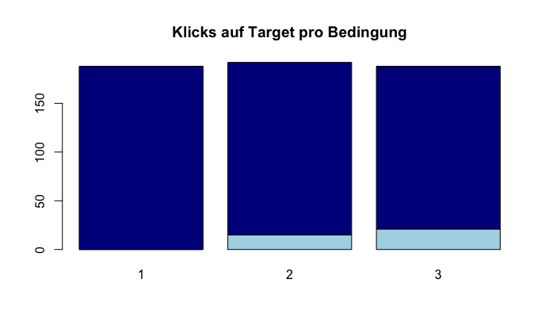

**Chi2-Test:**

Für die statistische Analyse habe ich die Daten in Bedingung 1 ausgeschlossen, um mir wirklich nur den Unterschied zwischen den Klicks (bezogen auf das Target oder nicht das Target) in Bedingung 2 und 3 anzusehen.

data: clicks_subset$Target and clicks_subset$Condition

X-squared = 0.8879, df = 1, p-value = 0.346

**Subset der Klickdaten**

* Daten: Klicks sind entweder auf das Target oder auf den Competitor in Bedingung 2 und 3

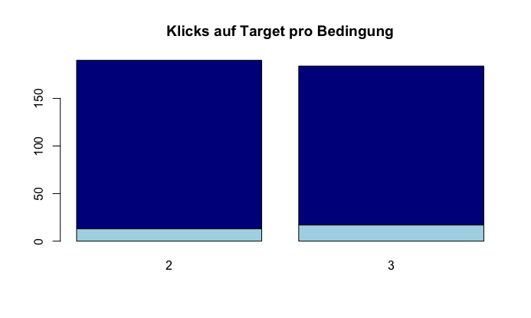

**Chi2-Test:**

Für die statistische Analyse habe ich die Daten in Bedingung 1 ausgeschlossen, um mir wirklich nur den Unterschied zwischen den Klicks (bezogen auf das Target oder nicht das Target) in Bedingung 2 und 3 anzusehen.

data: clicks_subset$Target and clicks_subset$Condition

X-squared = 0.43932, df = 1, p-value = 0.5075

**Onlinedaten nur Targets**

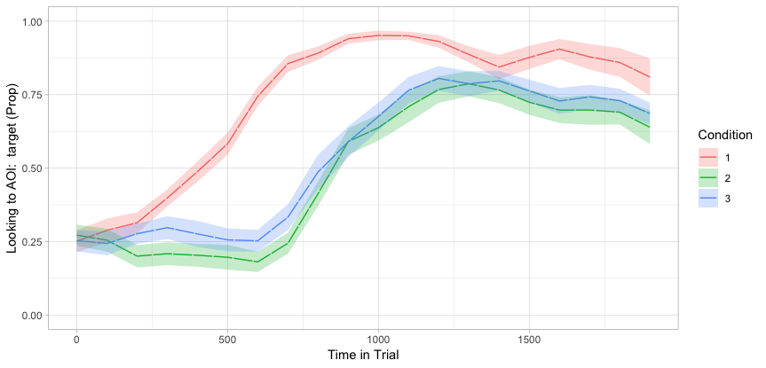

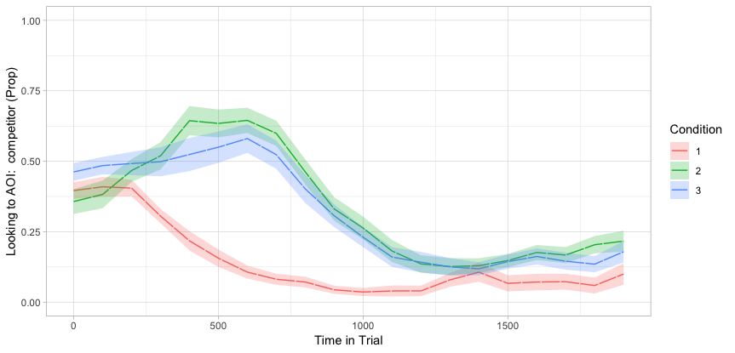

**Time: 0-1000ms**

Linear mixed model fit by maximum likelihood . t-tests use Satterthwaite's method ['lmerModLmerTest']

Formula: Elog ~ Condition + (1 + Condition | Item) + (1 + Condition | Participant)

Data: threeCond_first_agg

AIC BIC logLik deviance df.resid

2278.6 2344.9 -1123.3 2246.6 451

Scaled residuals:

Min 1Q Median 3Q Max

-2.45945 -0.51123 0.03471 0.56927 3.02000

Random effects:

Groups Name Variance Std.Dev. Corr

Item (Intercept) 0.79966 0.8942

Condition2-1 0.45189 0.6722 -0.28

Condition3-2 0.39778 0.6307 0.37 0.79

Participant (Intercept) 0.12075 0.3475

Condition2-1 0.07765 0.2787 1.00

Condition3-2 0.32516 0.5702 1.00 1.00

Residual 6.33960 2.5179

Number of obs: 467, groups: Item, 30; Participant, 20

Fixed effects:

Estimate Std. Error df t value Pr(>|t|)

(Intercept) -0.8781 0.2165 27.0707 -4.057 0.000379 ***

Condition2-1 -2.6405 0.3231 42.1692 -8.173 3.12e-10 ***

Condition3-2 0.4014 0.3342 34.2199 1.201 0.237945

---

Signif. codes: 0 ‘***’ 0.001 ‘**’ 0.01 ‘*’ 0.05 ‘.’ 0.1 ‘ ’ 1

Correlation of Fixed Effects:

(Intr) Cnd2-1

Conditin2-1 -0.031

Conditin3-2 0.240 -0.198

convergence code: 0

singular fit

**Time: 1000-2000ms**

Linear mixed model fit by maximum likelihood . t-tests use Satterthwaite's method ['lmerModLmerTest']

Formula: Elog ~ Condition + (1 + Condition | Item) + (1 + Condition | Participant)

Data: threeCond_snd_agg

AIC BIC logLik deviance df.resid

2434 2501 -1201 2402 472

Scaled residuals:

Min 1Q Median 3Q Max

-3.4824 -0.6894 0.1488 0.6789 2.1514

Random effects:

Groups Name Variance Std.Dev. Corr

Item (Intercept) 1.2275 1.1079

Condition2-1 0.2816 0.5306 1.00

Condition3-2 0.2691 0.5188 1.00 1.00

Participant (Intercept) 0.3882 0.6231

Condition2-1 0.3354 0.5791 0.17

Condition3-2 0.4507 0.6714 0.05 -0.98

Residual 7.0439 2.6540

Number of obs: 488, groups: Item, 30; Participant, 20

Fixed effects:

Estimate Std. Error df t value Pr(>|t|)

(Intercept) 2.9618 0.2747 32.4763 10.781 2.91e-12 ***

Condition2-1 -2.2787 0.3387 25.2168 -6.728 4.53e-07 ***

Condition3-2 0.2791 0.3496 22.3613 0.798 0.433

---

Signif. codes: 0 ‘***’ 0.001 ‘**’ 0.01 ‘*’ 0.05 ‘.’ 0.1 ‘ ’ 1

Correlation of Fixed Effects:

(Intr) Cnd2-1

Conditin2-1 0.247

Conditin3-2 0.216 -0.463

convergence code: 0

singular fit

**Onlinedaten nur Targets**

**Time: 0-1000ms**

Linear mixed model fit by maximum likelihood . t-tests use Satterthwaite's method ['lmerModLmerTest']

Formula: Elog ~ Condition + (1 + Condition | Item) + (1 + Condition | Participant)

Data: threeCond_targfirst_agg

AIC BIC logLik deviance df.resid

2114.7 2179.8 -1041.3 2082.7 418

Scaled residuals:

Min 1Q Median 3Q Max

-2.46503 -0.50799 0.00397 0.57714 2.96934

Random effects:

Groups Name Variance Std.Dev. Corr

Item (Intercept) 0.80001 0.8944

Condition2-1 0.51791 0.7197 -0.18

Condition3-2 0.42282 0.6502 0.24 0.91

Participant (Intercept) 0.12317 0.3510

Condition2-1 0.07482 0.2735 1.00

Condition3-2 0.35413 0.5951 1.00 1.00

Residual 6.21499 2.4930

Number of obs: 434, groups: Item, 30; Participant, 20

Fixed effects:

Estimate Std. Error df t value Pr(>|t|)

(Intercept) -0.8591 0.2191 27.8610 -3.921 0.000522 ***

Condition2-1 -2.5973 0.3306 46.3357 -7.857 4.59e-10 ***

Condition3-2 0.3667 0.3510 37.0064 1.045 0.303006

---

Signif. codes: 0 ‘***’ 0.001 ‘**’ 0.01 ‘*’ 0.05 ‘.’ 0.1 ‘ ’ 1

Correlation of Fixed Effects:

(Intr) Cnd2-1

Conditin2-1 0.012

Conditin3-2 0.218 -0.182

convergence code: 0

singular fit

**Time: 1000-2000ms**

Linear mixed model fit by maximum likelihood . t-tests use Satterthwaite's method ['lmerModLmerTest']

Formula: Elog ~ Condition + (1 + Condition | Item) + (1 + Condition | Participant)

Data: threeCond_targsnd_agg

AIC BIC logLik deviance df.resid

2223.3 2289.2 -1095.6 2191.3 440

Scaled residuals:

Min 1Q Median 3Q Max

-3.2943 -0.7313 0.1728 0.7851 1.6041

Random effects:

Groups Name Variance Std.Dev. Corr

Item (Intercept) 0.2791 0.5283

Condition2-1 0.1114 0.3338 -1.00

Condition3-2 0.1221 0.3494 1.00 -1.00

Participant (Intercept) 0.2477 0.4977

Condition2-1 0.3838 0.6195 -0.12

Condition3-2 0.6526 0.8078 -0.07 -0.98

Residual 6.6308 2.5750

Number of obs: 456, groups: Item, 30; Participant, 20

Fixed effects:

Estimate Std. Error df t value Pr(>|t|)

(Intercept) 3.2885 0.1918 20.0936 17.145 1.83e-13 ***

Condition2-1 -1.8690 0.3312 23.4480 -5.643 8.96e-06 ***

Condition3-2 0.4624 0.3604 20.9105 1.283 0.214

---

Signif. codes: 0 ‘***’ 0.001 ‘**’ 0.01 ‘*’ 0.05 ‘.’ 0.1 ‘ ’ 1

Correlation of Fixed Effects:

(Intr) Cnd2-1

Conditin2-1 -0.102

Conditin3-2 0.084 -0.614

convergence code: 0

singular fit